Bhartiyam International School
Pre – Mid Term Assessment (2022-23)
Subject: CHEMISTRY (SET B)
Class: XI
Date: 03/08/2022 Max. Mark: 40
Name: ______________ Roll No: ______ Duration: 1 hr 30 min
General instructions:-
- This question paper contain 3 sections.
- SECTION A consist of five questions carrying 1 mark each.
- SECTION B consist of five questions carrying 3 marks each.
- SECTION C consist of four questions carrying 5 marks each.

SECTION- A
Q.1- Calculate the wavelength of an electron moving with a velocity of 4.05 × 10⁶ ms⁻¹. 1
Q.2- Find out atomic number, mass number, number of electrons and neutrons in an element
₃₀X⁶⁵ 1
Q.3- What do you mean by isoelectronic species? Give examples. 1
Q.4- Which quantum number determines-
(i) Energy of electron (ii) Orientation of orbitals 1
Q.5- Why can not the motion of an electron around the nucleus be determined accurately? 1
SECTION- B
Q.6- . Which elements have the following electronic configurations? Give the name and symbol of each element. (Use only the periodic table.) 3
- 1s², 2s², 2p⁵
- [Ar] 4s², 3d¹⁰, 4p¹
- [Xe] 6s²
- [Xe] 6s², 5d¹, 4f⁷
- [Ar] 4s¹, 3d¹⁰ (exception to rules)
- [Ne] 3s², 3p⁶, 4s¹
Q.7- (i) Write the atomic number of the element in which filling of 3d sub-shell just starts. 3
(ii)Write outer electronic configuration of Cr atom. Why are half filled orbitals more stable?
Q.8- Define the following-
(i) Magnetic quantum number. (ii) Modern periodic law (iii) Hund’s rule 3
Q.9- Write the electronic configuration of (i) Zn²⁺ (ii)Al³⁺ (iii) Cr⁺ Mention the number of
unpaired electrons in each case. 3
Q.10- Arrange the electrons represented by the following sets of quantum numbers in decreasing order of energy.
1. n=2, l=0, m=0, s=-1/2 2. n=5, l=2, m=-2, s=−1/2 3. n=3, l=1, m=0, s=+1/2 3

SECTION- C
Q.11- (i)Which rule is violated in the following orbital diagram-
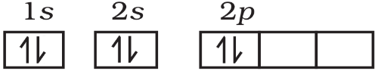
(ii) How do ionic radii vary with effective nuclear charge? Give example.
(iii) An element belongs to 3rd period and group-13 of the periodic table. Identify the element and write two properties of element. 5
Q.12-(i) Which pair of element show similar properties with following atomic number?
[13, 31], [11, 21]
(ii) Lithium shows diagonal relationship with which element and why?
(iii) Give reason for the following:
- Anionic radius is always more than that of neutral atom.
- Ionization enthalpy of nitrogen is more than that of oxygen. 5
Q.13- Give the main features of s-block elements, write the symbols with atomic numbers of all the – s-block elements. 5
Q.14 (i) Why the electron gain enthalpy of fluorine is less negative than that of chlorine?
(ii) Write down the outermost electronic configuration of alkali metals. How will you justify their placement in group 1 of the periodic table?
(iii) Arrange the elements N, P, O and S in the order of-
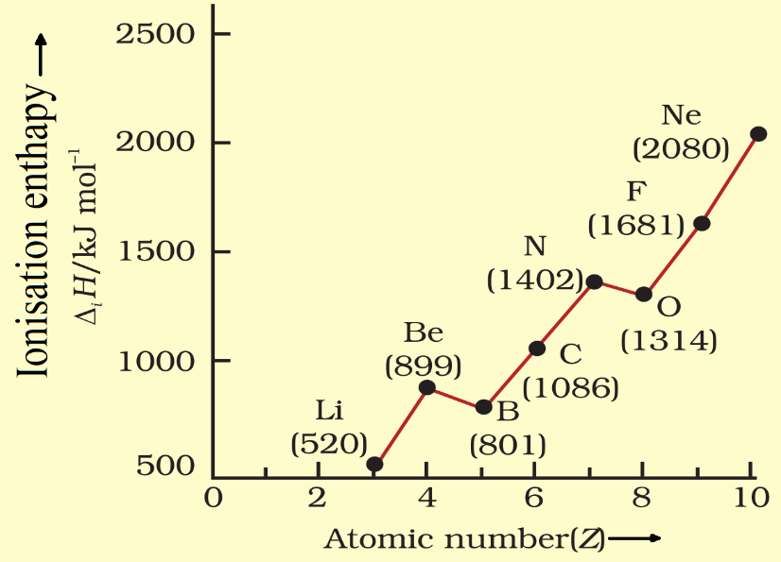
- Increasing first ionisation enthalpy.
- Increasing non metallic character.

